18.50: a) The pressure must be above the triple point, 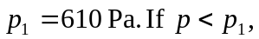 the water cannot exist in the liquid phase, and the phase transition is from solid to vapor (sublimation). b) 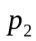 is the critical pressure, 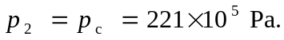 For pressures below but above 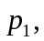 the phase transition is the most commonly observed sequence, solid to liquid to vapor, or ice to water to steam.

